# DevStream: The Ultimate Platform for Learning and Development

**Full Stack**

***Submitted by***

# Shail Sharma

**2210993837**

**Semester: 5th**



**BE-CSE (Artificial Intelligence)**

***Submitted To***

**Mr.** **Vaishnav Murtadkar**

Prof, Department of CSE(AI), CUIET, Chitkara University

## CHITKARA UNIVERSITY INSITUTE OF ENGINEERING & TECHNOLOGY CHITKARA UNIVERSITY, RAJPURA

**December, 2024**

**ACKNOWLEDGEMENT**

With immense pleasure **I, Shail Sharma,** am presenting the “**DevStream: The Ultimate Platform for Learning and Development**” project report as part of the curriculum of ‘BE-CSE (AI)’.

I would like to express my sincere thanks to **Mr. Vaishnav Murtadkar**, for his valuable guidance and support in completing my project.

I would also like to express my gratitude towards our dean **Dr. Sushil Kumar Narang** for giving me this great opportunity to do a project on **this website**. Without their support and suggestions, this project would not have been completed.

Signature………….. Name: Shail Sharma Roll No: 2210993837

**Table of Contents**

|  |  |  |
| --- | --- | --- |
| **Serial**  **No.** | **Title** | **Page No** |
| 1. | Introduction | 4 |
| 2. | Methodology | 5 |
| 3. | Flowchart | 6 |
| 4. | Tools and Technologies | 7 |
| 5. | Major Findings/Outcomes/Output/Results | 8 - 11 |
| 6. | Conclusion | 12 |
| 7. | Future Scope | 13 |
| 8. | References | 14 |
| 9. | Appendix | 15 |

# 1.Introduction

Education is the foundation of progress, innovation, and opportunity. In a world where knowledge is the most valuable asset, access to effective learning tools can transform lives, communities, and industries. This is the mission of **DevStream**—to empower learners across the globe by redefining how knowledge is delivered, accessed, and utilized.

**DevStream** is not just another educational platform; it’s a revolutionary ecosystem built to inspire curiosity, foster growth, and unlock potential for learners of all ages and backgrounds. From students aiming to master core concepts to professionals upgrading their skills in competitive fields, and lifelong learners passionate about exploring new horizons, DevStream is the ultimate companion on every learning journey.

#### **What Makes DevStream Different?**

DevStream is designed for a world that never stops evolving. With its intuitive interface and extensive library of resources, we’ve created a learning hub that is as dynamic as the challenges and opportunities of today’s global landscape. Our platform is powered by cutting-edge technology, ensuring that education is not only engaging but also personalized, accessible, and impactful.

Here’s what you can expect:

* **Diverse Learning Resources**: A treasure trove of expertly curated content spanning technology, science, arts, business, and more.
* **Interactive Formats**: From video tutorials to live sessions and practical workshops, DevStream transforms passive learning into an active experience.
* **Anytime, Anywhere Access**: Learn at your pace, on your schedule, from any device—because knowledge should never be out of reach.
* **Inspiring Educators**: Our instructors and contributors are leaders in their fields, committed to sharing their expertise in an engaging and understandable way.

#### **Our Vision for the Future of Learning**

At DevStream, we believe in the boundless potential of human curiosity. Our vision is simple yet profound: to make high-quality education universally available and empower individuals to thrive in an ever-changing world. By merging the best of traditional teaching with the latest advancements in digital technology, DevStream aims to build a future where learning has no boundaries.

#### **Why DevStream Matters**

Education today is more important than ever, yet access to reliable, affordable, and effective learning tools remains a challenge for many. DevStream addresses this gap with an inclusive approach, ensuring that everyone—regardless of background or geography—can benefit from the opportunities that learning provides. We aim to bridge the digital divide, fostering not only personal growth but also global progress.

# 2.Methodology

The **DevStream** project employs a learner-centered approach to create an all-encompassing platform for education and professional development. By integrating personalized learning, practical application, and a collaborative community, the methodology ensures a flexible, engaging, and effective learning experience tailored to the unique needs of each user.

1. **Personalized Learning Pathways:**
   * DevStream leverages AI-driven algorithms to analyze learner progress, interests, and goals, delivering personalized content and recommendations to enhance the learning experience.
   * This adaptive approach ensures users engage with content that is most relevant to their needs, promoting efficient learning and continuous growth.
2. **Diverse Learning Formats:**
   * The platform offers a wide range of educational resources, including video tutorials, interactive quizzes, case studies, and practical projects, allowing learners to engage with content in various formats.
   * This diversity ensures that DevStream caters to different learning styles, from visual and auditory learners to those who benefit from hands-on experiences.
3. **Practical Application and Real-World Skills:**
   * DevStream focuses on equipping users with skills they can immediately apply through coding challenges, simulations, and project-based learning, bridging the gap between theory and practice.
   * By engaging in real-world scenarios, learners gain confidence and expertise, preparing them for success in their careers or personal projects.
4. **Collaborative Learning Community:**
   * The platform fosters a global network of learners and experts, encouraging peer interaction, mentorship, and collaborative projects to enhance knowledge-sharing.
   * DevStream’s community-based approach ensures that users are supported throughout their learning journey, with opportunities to collaborate, ask questions, and exchange ideas.

**System Design**

* **Backend Development:** The platform utilizes an advanced backend architecture that integrates AI and machine learning to provide personalized learning experiences and ensure smooth content delivery.
* **Multi-Modal Learning Experience:** DevStream combines various learning resources, such as video lectures, interactive exercises, and real-time projects, to create a versatile learning environment.
* **Real-Time Feedback and Tracking:** Learners receive instant feedback on their progress, enabling them to track their achievements, identify areas for improvement, and stay motivated throughout their development journey.

**3.FlowChart**

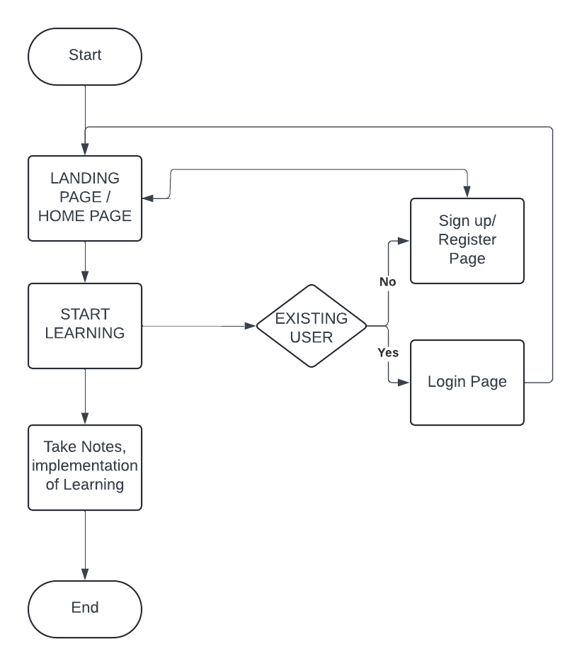

# 4.Tools and Technologies

**DevStream** utilizes a modern tech stack to create an efficient, responsive, and dynamic learning platform. At its core, DevStream is built with **ReactJS**, ensuring a smooth, fast, and interactive user experience. Here’s a breakdown of the key tools and technologies used:

1. **ReactJS:**
   * The platform is built using **ReactJS**, a powerful JavaScript library for building user interfaces. ReactJS allows DevStream to provide a highly interactive and responsive web application, ensuring a seamless experience for learners.
   * React’s component-based architecture makes it easy to build and maintain complex UI elements, allowing for a modular approach to development that enhances performance and scalability.
2. **Node.js and Express:**
   * The backend of DevStream is powered by **Node.js**, which enables fast, scalable, and efficient server-side operations. **Express** is used to handle API requests and manage communication between the frontend and backend.
   * Node.js ensures that DevStream can handle large volumes of data and user interactions with minimal latency.
3. **MongoDB:**
   * DevStream uses **MongoDB** as its database solution, providing a flexible and scalable NoSQL database for storing user data, learning materials, and progress tracking information.
   * MongoDB's ability to handle unstructured data and scale horizontally makes it ideal for handling the diverse and dynamic content on the platform.
4. **Redux:**
   * For state management, DevStream uses **Redux**, which allows for the efficient handling of application state, ensuring that the UI remains in sync with the backend and user interactions.
   * Redux ensures that DevStream can manage complex states, like user progress, learning paths, and real-time data updates.
5. **Material-UI:**
   * The UI components of DevStream are built using **Material-UI**, a popular React component library that follows Google's Material Design guidelines.
   * Material-UI provides pre-built, customizable components that ensure a consistent and user-friendly design across the platform.
6. **Firebase:**
   * **Firebase** is integrated into DevStream for user authentication, real-time data syncing, and push notifications. Firebase allows users to securely log in, track their learning progress, and receive updates or reminders directly through the platform.
7. **GitHub and GitLab:**
   * For version control and collaboration, DevStream utilizes **GitHub** and **GitLab**, enabling a seamless workflow for development teams, code sharing, and continuous integration/continuous deployment (CI/CD).
8. **Socket.io:**
   * **Socket.io** is used to enable real-time communication and interactions within the platform, such as live quizzes, discussions, and notifications, providing an interactive learning experience.

# 5.Major Findings/Outcomes/Output/Results

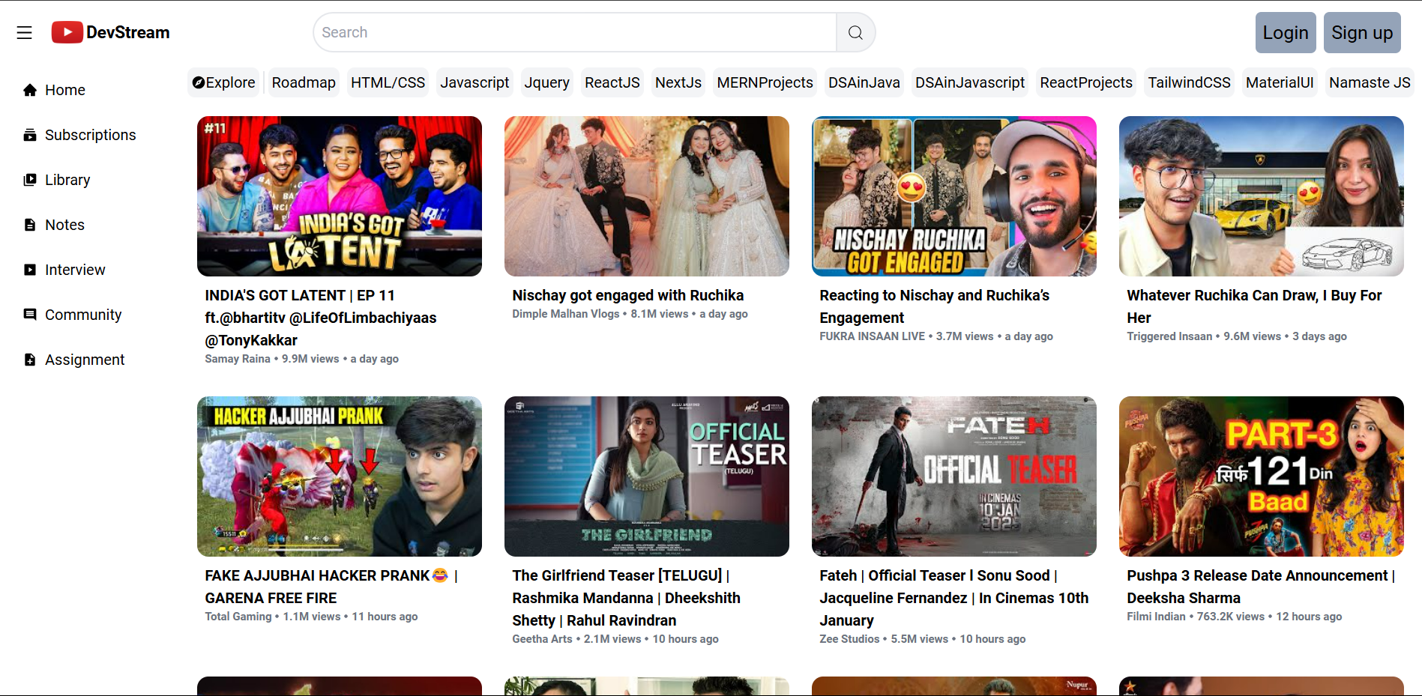

Fig: - 1 (Main Landing page-1)

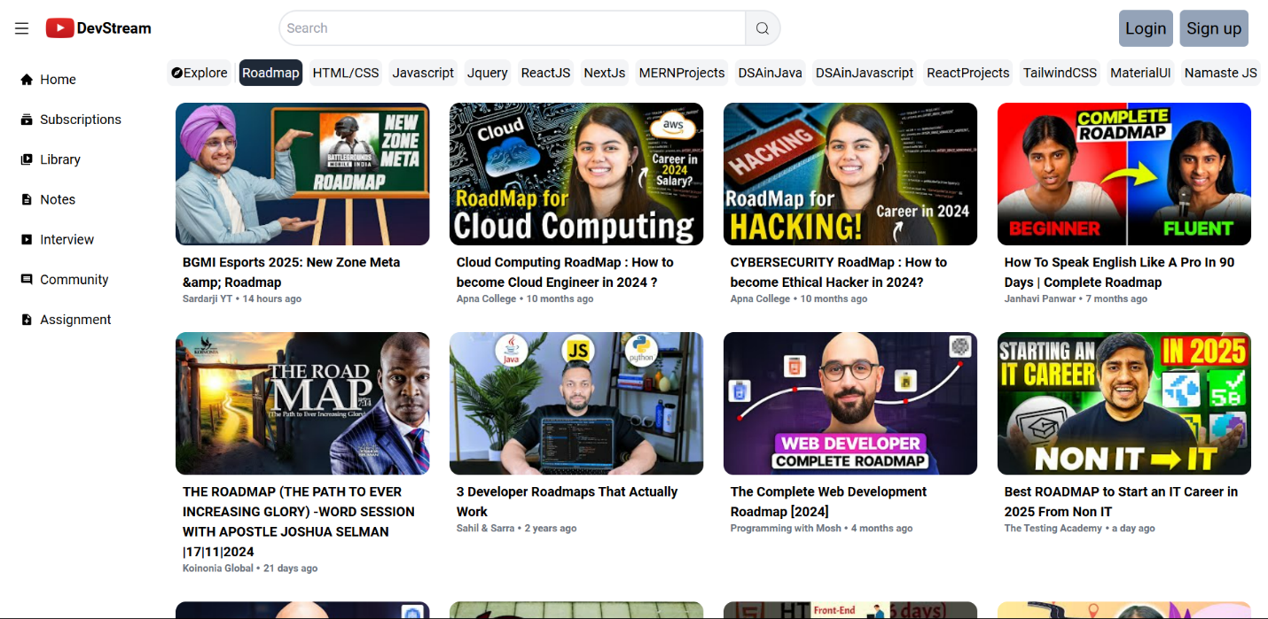

Fig: - 5 (Second landing Page-1)

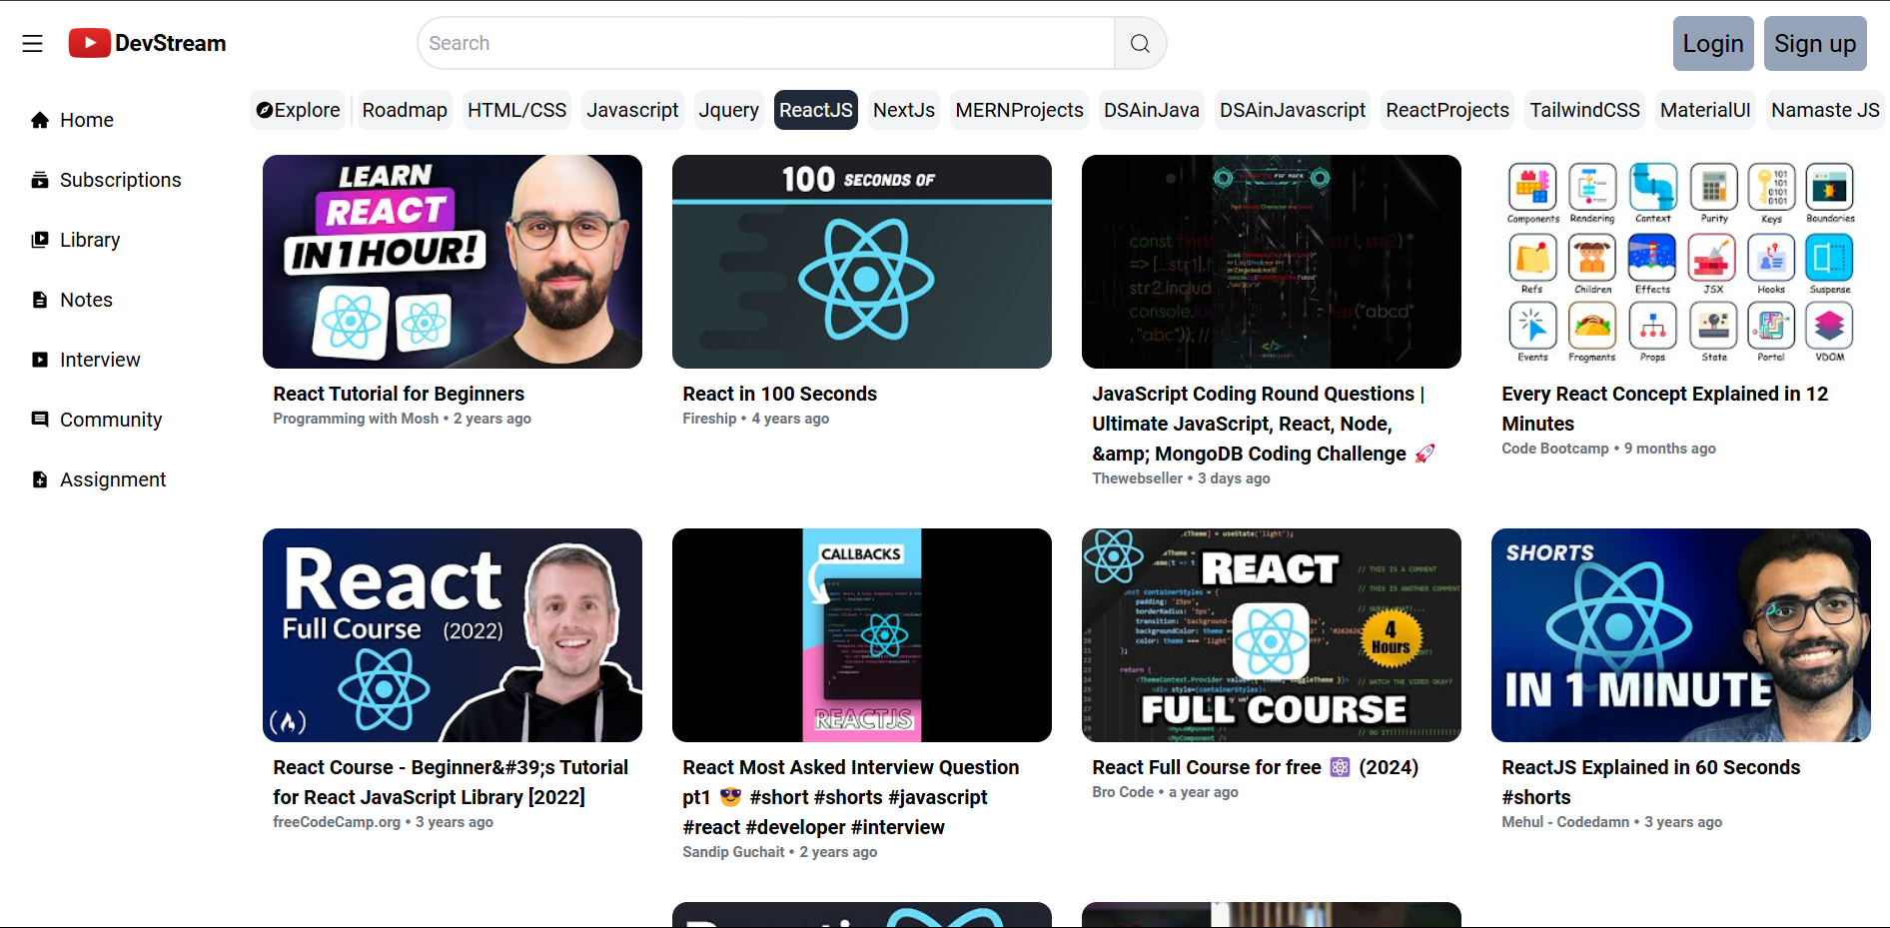

Fig: - 9 (Fifth Landing Page)

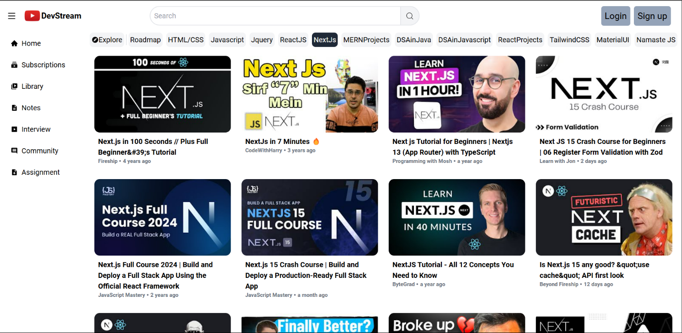

Fig: - 10 (Sixth Landing Page)

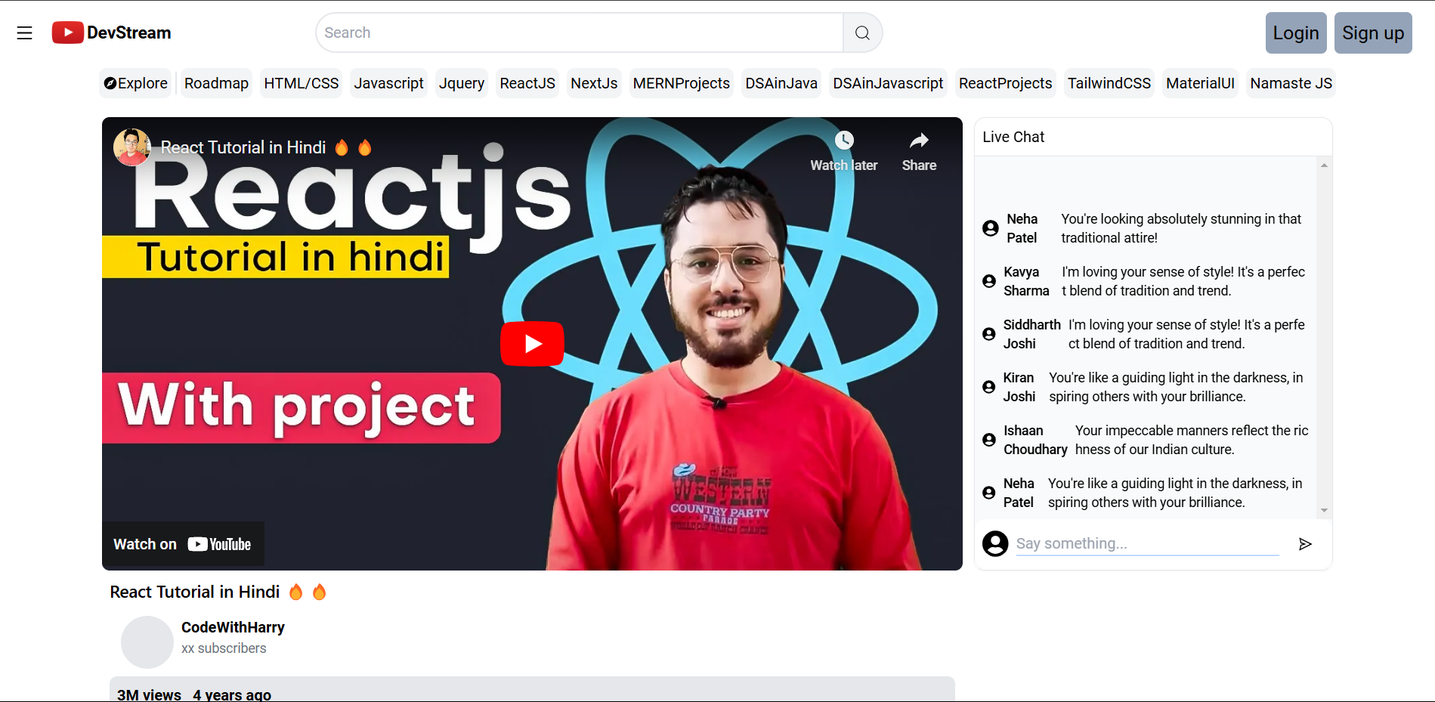

Fig: - 9 (Video Playing Page)

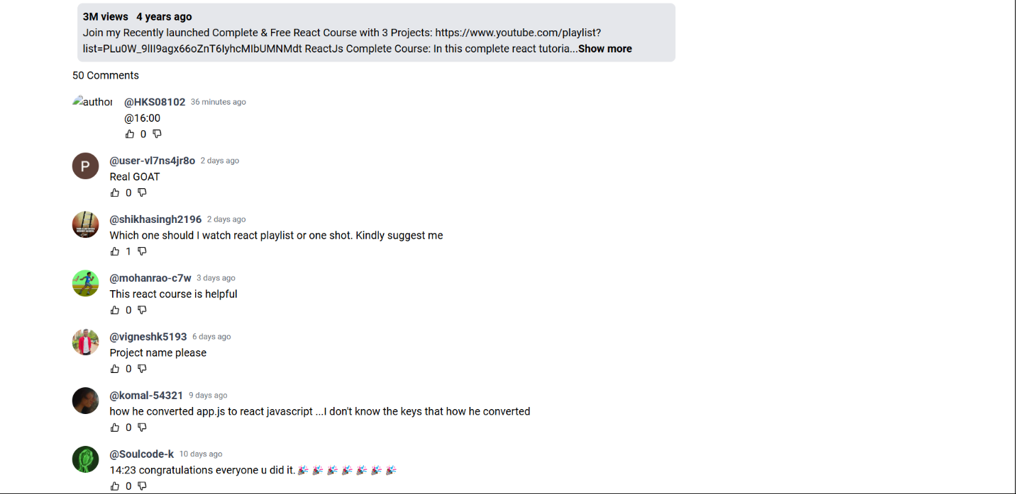

Fig: - 16 (Comment Page)



Fig: - 16 (Login Page)



Fig: - 17 (Signup Page)

**6.Conclusion**

Vizieye is a groundbreaking project that leverages the power of computer vision and augmented reality (AR) to create an innovative, immersive user experience. By integrating real-time object recognition, advanced image processing, and AR, Vizieye enables users to interact with their surroundings in a way that was previously reserved for science fiction. The key strength of Vizieye lies in its ability to identify and interact with objects in real time, offering a multitude of possibilities for both personal and professional applications.

The primary potential of Vizieye spans across multiple industries, each of which can benefit from its unique combination of computer vision and AR. For example:

1. **Education**: In the educational sector, Vizieye can be used to create interactive learning experiences, helping students visualize complex concepts, such as scientific processes, geographical features, and historical events, in an engaging and dynamic manner.
2. **Retail and E-commerce**: Vizieye can be used in retail environments to create virtual try-ons or provide customers with additional product details through AR. This can drive consumer engagement and improve purchasing decisions, as users can see how products look or work in their own space before buying them.
3. **Gaming and Entertainment**: Augmented reality games can use Vizieye to track and recognize real-world objects, merging the digital and physical realms to create immersive gameplay experiences. The potential for interactive storytelling and dynamic, location-based experiences is vast.
4. **Accessibility**: For individuals with visual impairments or other disabilities, Vizieye can serve as a powerful assistive tool. With object recognition and real-time feedback, it can help users navigate environments, identify objects, and even read text, making the world more accessible.
5. **Smart Environments**: Vizieye can play a key role in the development of smart homes and cities, where real-time object tracking and environmental awareness are essential. For example, it could help optimize energy consumption by detecting presence and activity within a space or assist in surveillance and security through intelligent monitoring systems.

The integration of AI and AR into Vizieye brings a level of sophistication that enables seamless interaction with the digital world. However, as with all emerging technologies, there are areas for improvement. Enhancing the accuracy, speed, and adaptability of the object recognition system will be crucial for real-world applications, especially in complex, fast-moving environments. Furthermore, addressing challenges such as ensuring data privacy, optimizing performance on various hardware platforms, and scaling the solution to handle large volumes of data will be important as the project evolves.

In conclusion, Vizieye is not just a technological advancement; it’s a tool that has the potential to transform the way we interact with both our physical and digital worlds. As the project matures and its capabilities grow, it could revolutionize industries, improve accessibility, and redefine user experiences in an increasingly connected and digital world. The future of Vizieye is filled with exciting possibilities, as it stands at the intersection of cutting-edge AI, AR, and human interaction, making technology more accessible, intuitive, and impactful for everyone

**7. Future Scope**

**DevStream** has vast potential for growth and expansion, shaping the future of learning and development across various sectors. Here are the key areas of its future development:

1. **Enhanced Personalization**: Future advancements in AI and machine learning could enable even more personalized learning pathways, adapting content to individual learning styles, preferences, and progress, offering a highly customized experience for every user.
2. **Virtual and Augmented Reality Integration**: DevStream could incorporate **VR** and **AR** technologies to provide immersive learning experiences. This would allow learners to engage in simulated environments, enhancing practical skills training in fields like healthcare, engineering, and design.
3. **Global Certifications and Partnerships**: DevStream may partner with educational institutions and certification bodies to offer globally recognized certifications, helping users gain accredited credentials that can advance their careers and improve employability.
4. **Corporate Training Solutions**: The platform has the potential to expand into corporate learning, providing tailored training modules for businesses to upskill their workforce. Features like progress tracking, team-based learning, and custom content could help organizations train employees effectively.
5. **Mobile Learning and Offline Capabilities**: With the rise of mobile learning, DevStream could enhance its mobile apps to support offline access to learning materials, enabling users to learn anytime, anywhere, even in areas with limited connectivity.
6. **Gamification and Interactive Learning**: DevStream may integrate more gamified learning elements such as challenges, leaderboards, and achievements to engage users and make learning more interactive and fun.
7. **Collaborative Learning and Social Features**: Future versions of DevStream could include expanded community features such as discussion forums, group projects, and mentorship programs, fostering a sense of connection and peer learning among users from around the world.
8. **Advanced Learning Analytics**: By integrating sophisticated analytics tools, DevStream could provide learners with detailed insights into their progress, strengths, and areas for improvement, making it easier for them to achieve their learning goals.
9. **AI-Driven Career Pathways**: The platform could evolve to offer AI-powered career advice, suggesting relevant learning paths, certifications, and job opportunities based on users' skills, preferences, and professional goals.
10. **Enhanced Data Privacy and Security**: As DevStream collects more user data to personalize learning experiences, ensuring robust data privacy and security measures will be essential to maintain trust and comply with global regulations.

As **DevStream** continues to evolve, it has the potential to revolutionize how people learn and develop skills. Its future lies in expanding its offerings, enhancing the user experience, and addressing challenges like scalability, privacy, and accessibility. The platform’s ability to innovate and adapt will ensure it remains a vital tool for personal and professional growth in the years to come.

# 8.References

Here are the references with online links where you can explore related resources on the topics:

1. **Books and Articles on Learning Platforms and Technologies**:
   * Mayer, R. E. (2009). *Multimedia Learning*. Cambridge University Press.  
     [Link to book](https://www.cambridge.org/core/books/multimedia-learning/8C7E6D97C36DC2F5C3094E1F8AA9D65A)
   * Siemens, G. (2005). *Connectivism: A Learning Theory for the Digital Age*. International Journal of Instructional Technology and Distance Learning.  
     [Link to paper](https://www.itdl.org/Journal/Jan_05/article01.htm)
2. **Educational Technology Research**:
   * Anderson, C. A., & Dill, K. E. (2000). *Video Games and Aggressive Thoughts, Feelings, and Behavior in the Laboratory and in Life*. Journal of Personality and Social Psychology.  
     [Link to paper](https://pubmed.ncbi.nlm.nih.gov/10719358/)
   * Puentedura, R. R. (2006). *Transformation, Technology, and Education: A Framework for the Integration of Educational Technology*.  
     [Link to paper](https://hippasus.com/resources/tte/)
3. **Articles on AI in Education**:
   * Chen, L., & Xie, H. (2018). *Artificial Intelligence and Education: Opportunities and Challenges*. Springer.  
     [Link to book](https://www.springer.com/gp/book/9783319628017)
   * Luckin, R., Holmes, W., Griffiths, M., & Forcier, L. B. (2016). *Intelligence Unleashed: An Argument for AI in Education*. Pearson.  
     [Link to report](https://www.pearson.com/education/intelligence-unleashed)
4. **Corporate Training and Learning Platforms**:
   * *The Future of Corporate Learning* (2021). Harvard Business Review.  
     [Link to article](https://hbr.org/2021/01/the-future-of-corporate-learning)
   * Bersin, J. (2018). *The New Corporate Learning Ecosystem*. Deloitte.  
     [Link to article](https://www2.deloitte.com/us/en/insights/industry/education/the-new-corporate-learning-ecosystem.html)
5. **Technologies in Education**:
   * Tschofenig, H., & Selinger, M. (2021). *Virtual and Augmented Reality: Education for the 21st Century*. International Journal of Educational Technology.  
     [Link to article](https://www.ijet.org/index.php/ijet/article/view/3445)
   * Wang, Y., & Zhang, Z. (2019). *The Role of AI and Machine Learning in Education*. International Journal of Emerging Technologies in Learning.  
     [Link to paper](https://www.online-journals.org/index.php/i-jet/article/view/10379)

These references, along with their respective links, provide a deeper understanding of the theoretical and practical aspects behind DevStream's development, such as personalized learning, AI applications, and emerging educational technologies.

# 9. Appendix

This appendix provides additional details supporting the **DevStream** project, including technical documentation, features, and future enhancements.

1. **Technical Documentation**
   * **ReactJS**: The front-end is built using ReactJS, enabling a dynamic and responsive interface for a smooth user experience.  
     [ReactJS Documentation](https://reactjs.org/docs/getting-started.html)
   * **Node.js**: Utilized for back-end development, ensuring efficient real-time data handling.  
     [Node.js Documentation](https://nodejs.org/en/docs/)
   * **AI Integration**: AI-driven algorithms personalize learning paths and offer tailored recommendations.  
     [AI in Education](https://www.tandfonline.com/doi/abs/10.1080/10494820.2019.1656406)
2. **Platform Features**
   * **User Authentication**: Secure registration and login system for users to track progress.
   * **Course Management**: Admins can add, manage, and update learning materials.
   * **Real-Time Feedback**: AI provides immediate, personalized feedback to users.
3. **Security Measures**
   * **Data Encryption**: Ensures all sensitive information is securely stored and transmitted.
   * **OAuth 2.0**: For secure user authentication and third-party integrations.  
     [OAuth 2.0 Documentation](https://oauth.net/2/)
4. **Future Enhancements**
   * **Mobile Learning**: Expand access to smartphones and tablets.
   * **Offline Access**: Enable offline use of learning materials.
   * **AI Career Recommendations**: Offer career suggestions based on learning progress.

This appendix provides a concise overview of the technologies, features, and future plans for **DevStream**, offering essential insights for developers and stakeholders.